THE FRAZIER FOOT & ANKLE CENTER
12609 LOUETTA RD SUITE B
CYPRESS, TX 77429
PH: 281-720-8267
FAX: 281-606-0402

Patient Information Form

Date: ____/_____/_____

Patient Name: _________________ _________________ ____ Date of Birth: ____/____/____ Age: ____ Sex: M F
Last First MI
Current Problem
What specific problem brings you to our office today? __________________________________________________

__________________________________________________________________________________________________________________________________________________________________________________________________________________________________

Where is the pain/problem located? Please mark on the pictures below.

Left Foot Right foot
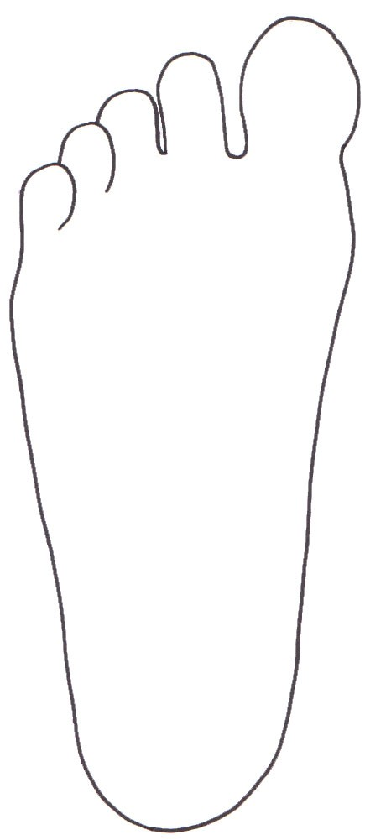
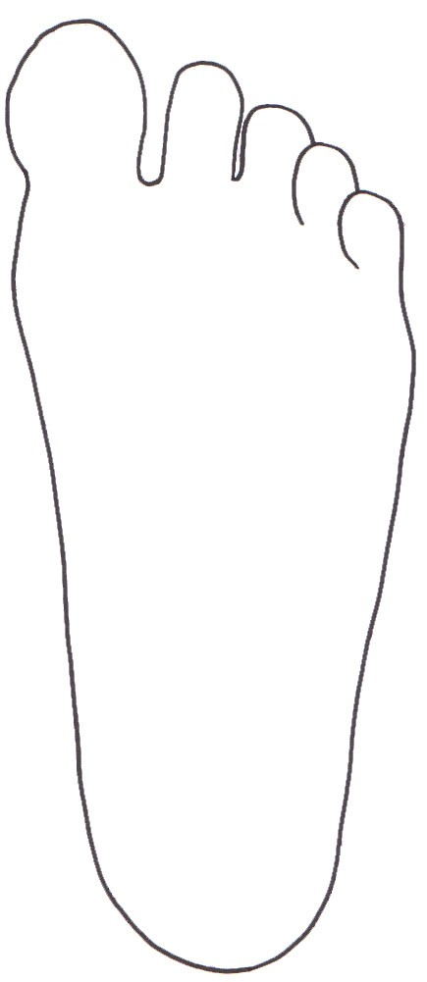
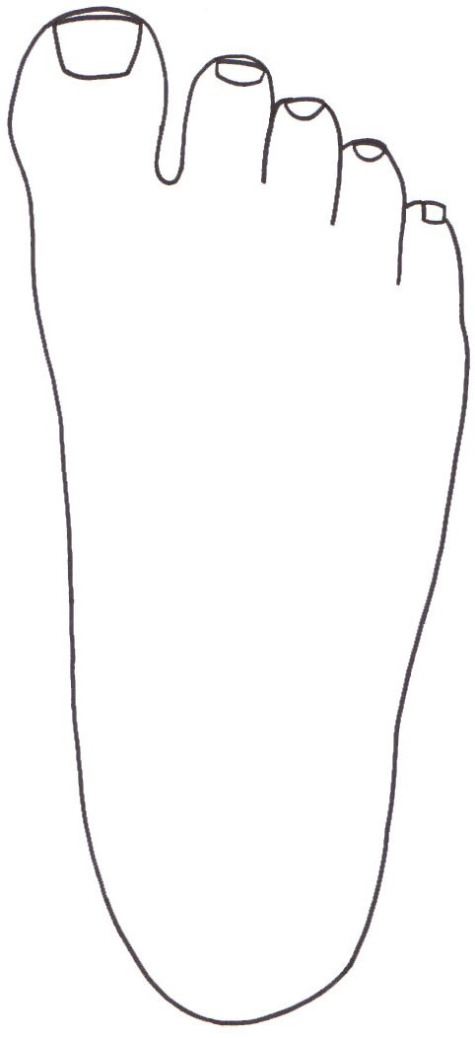
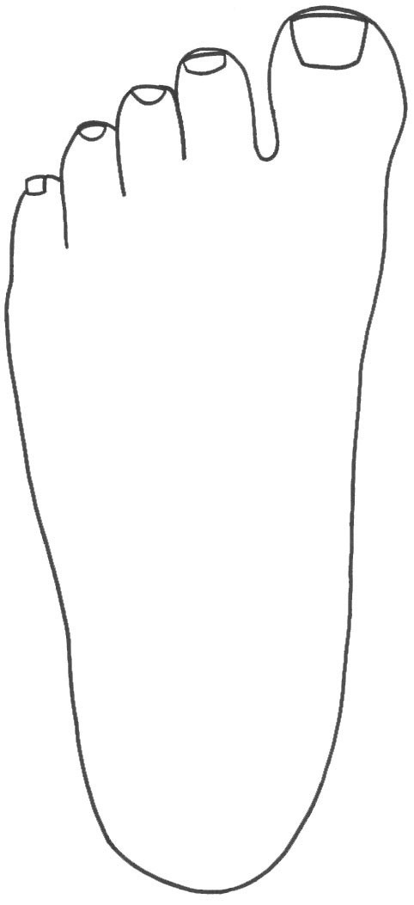

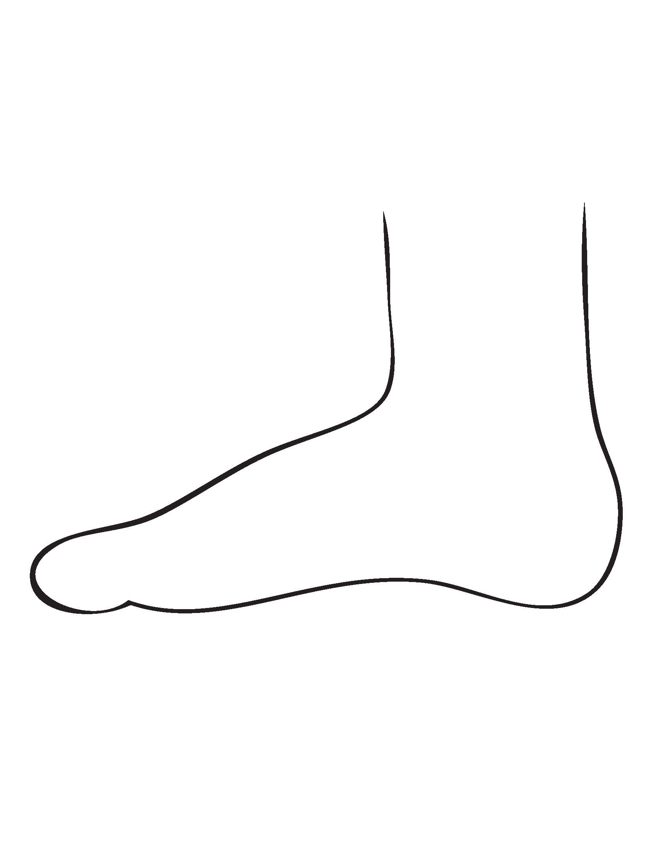
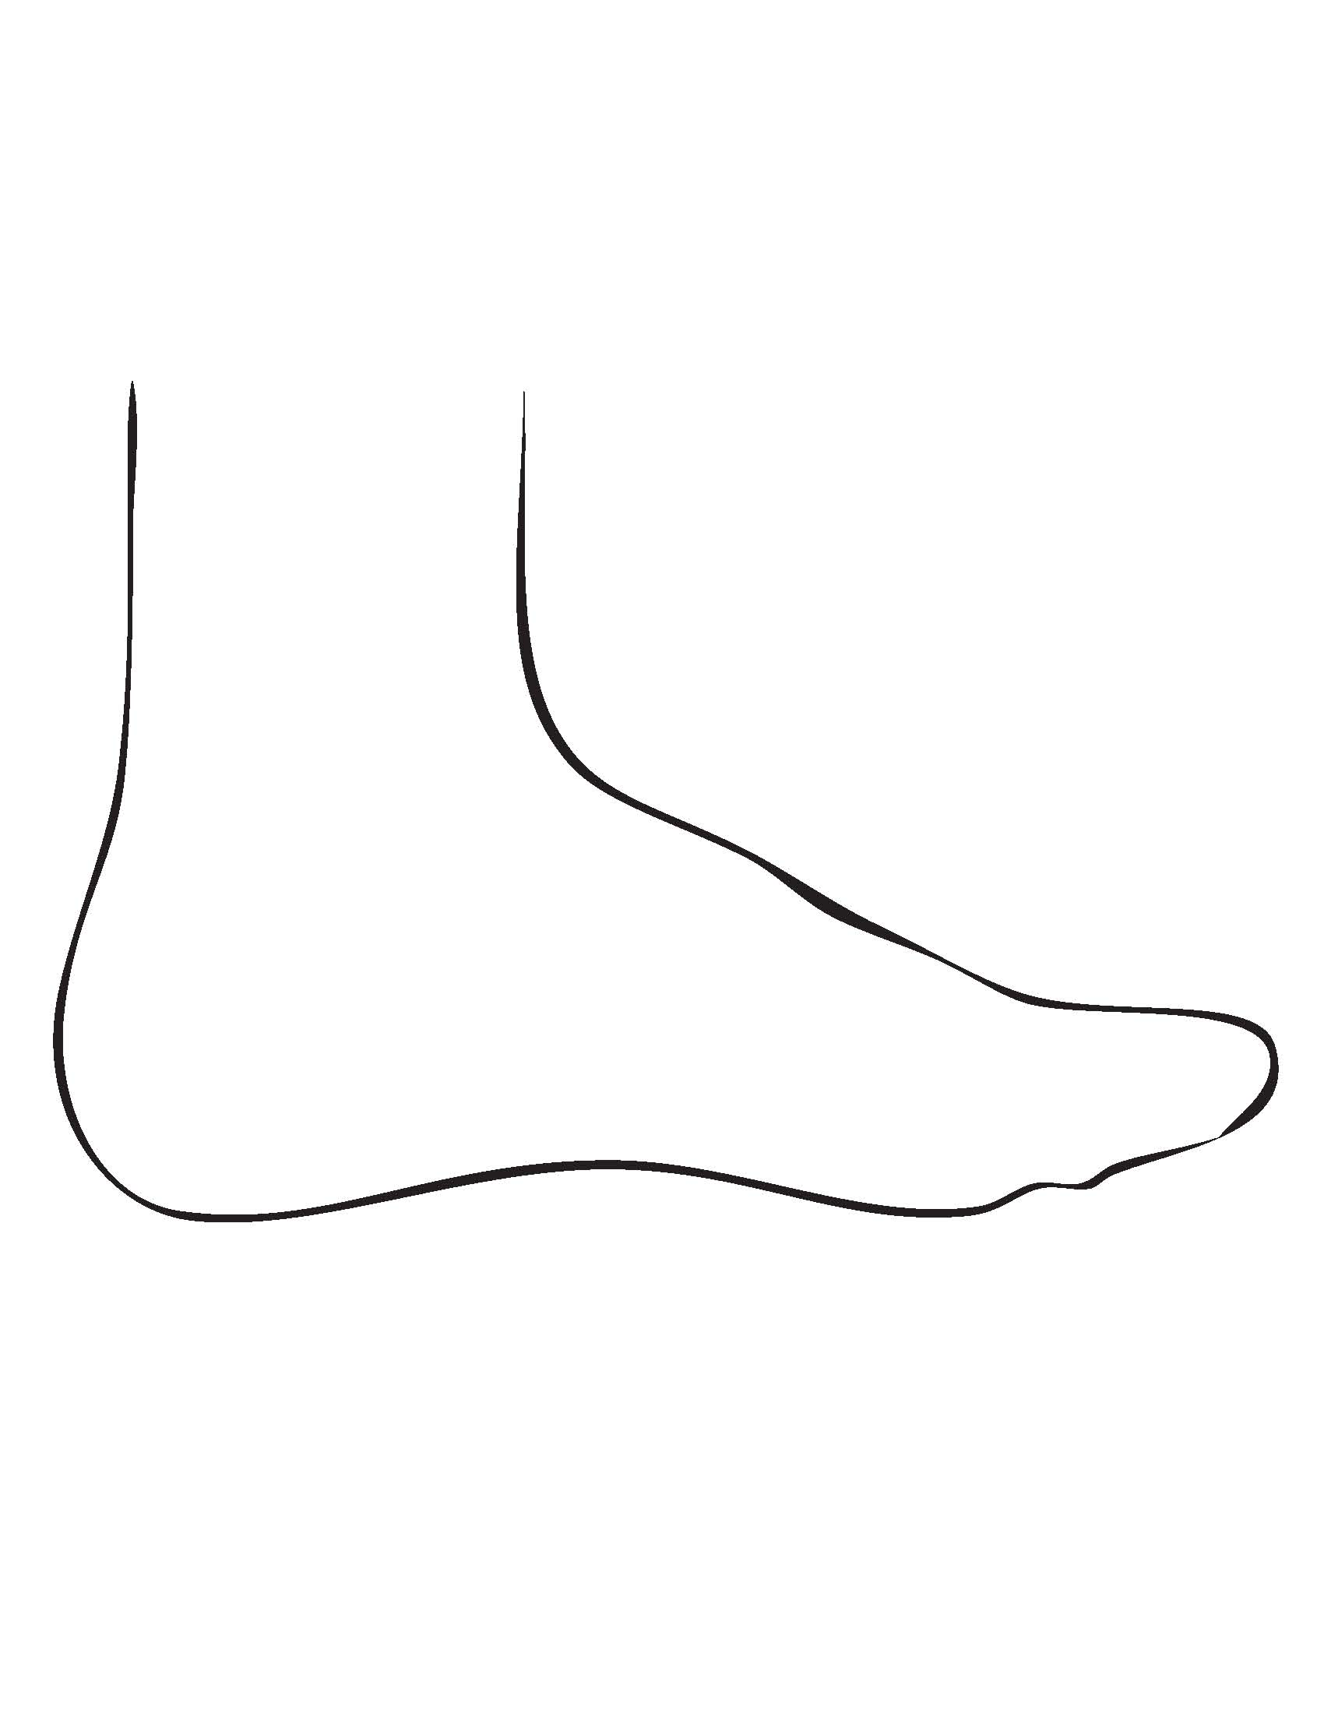
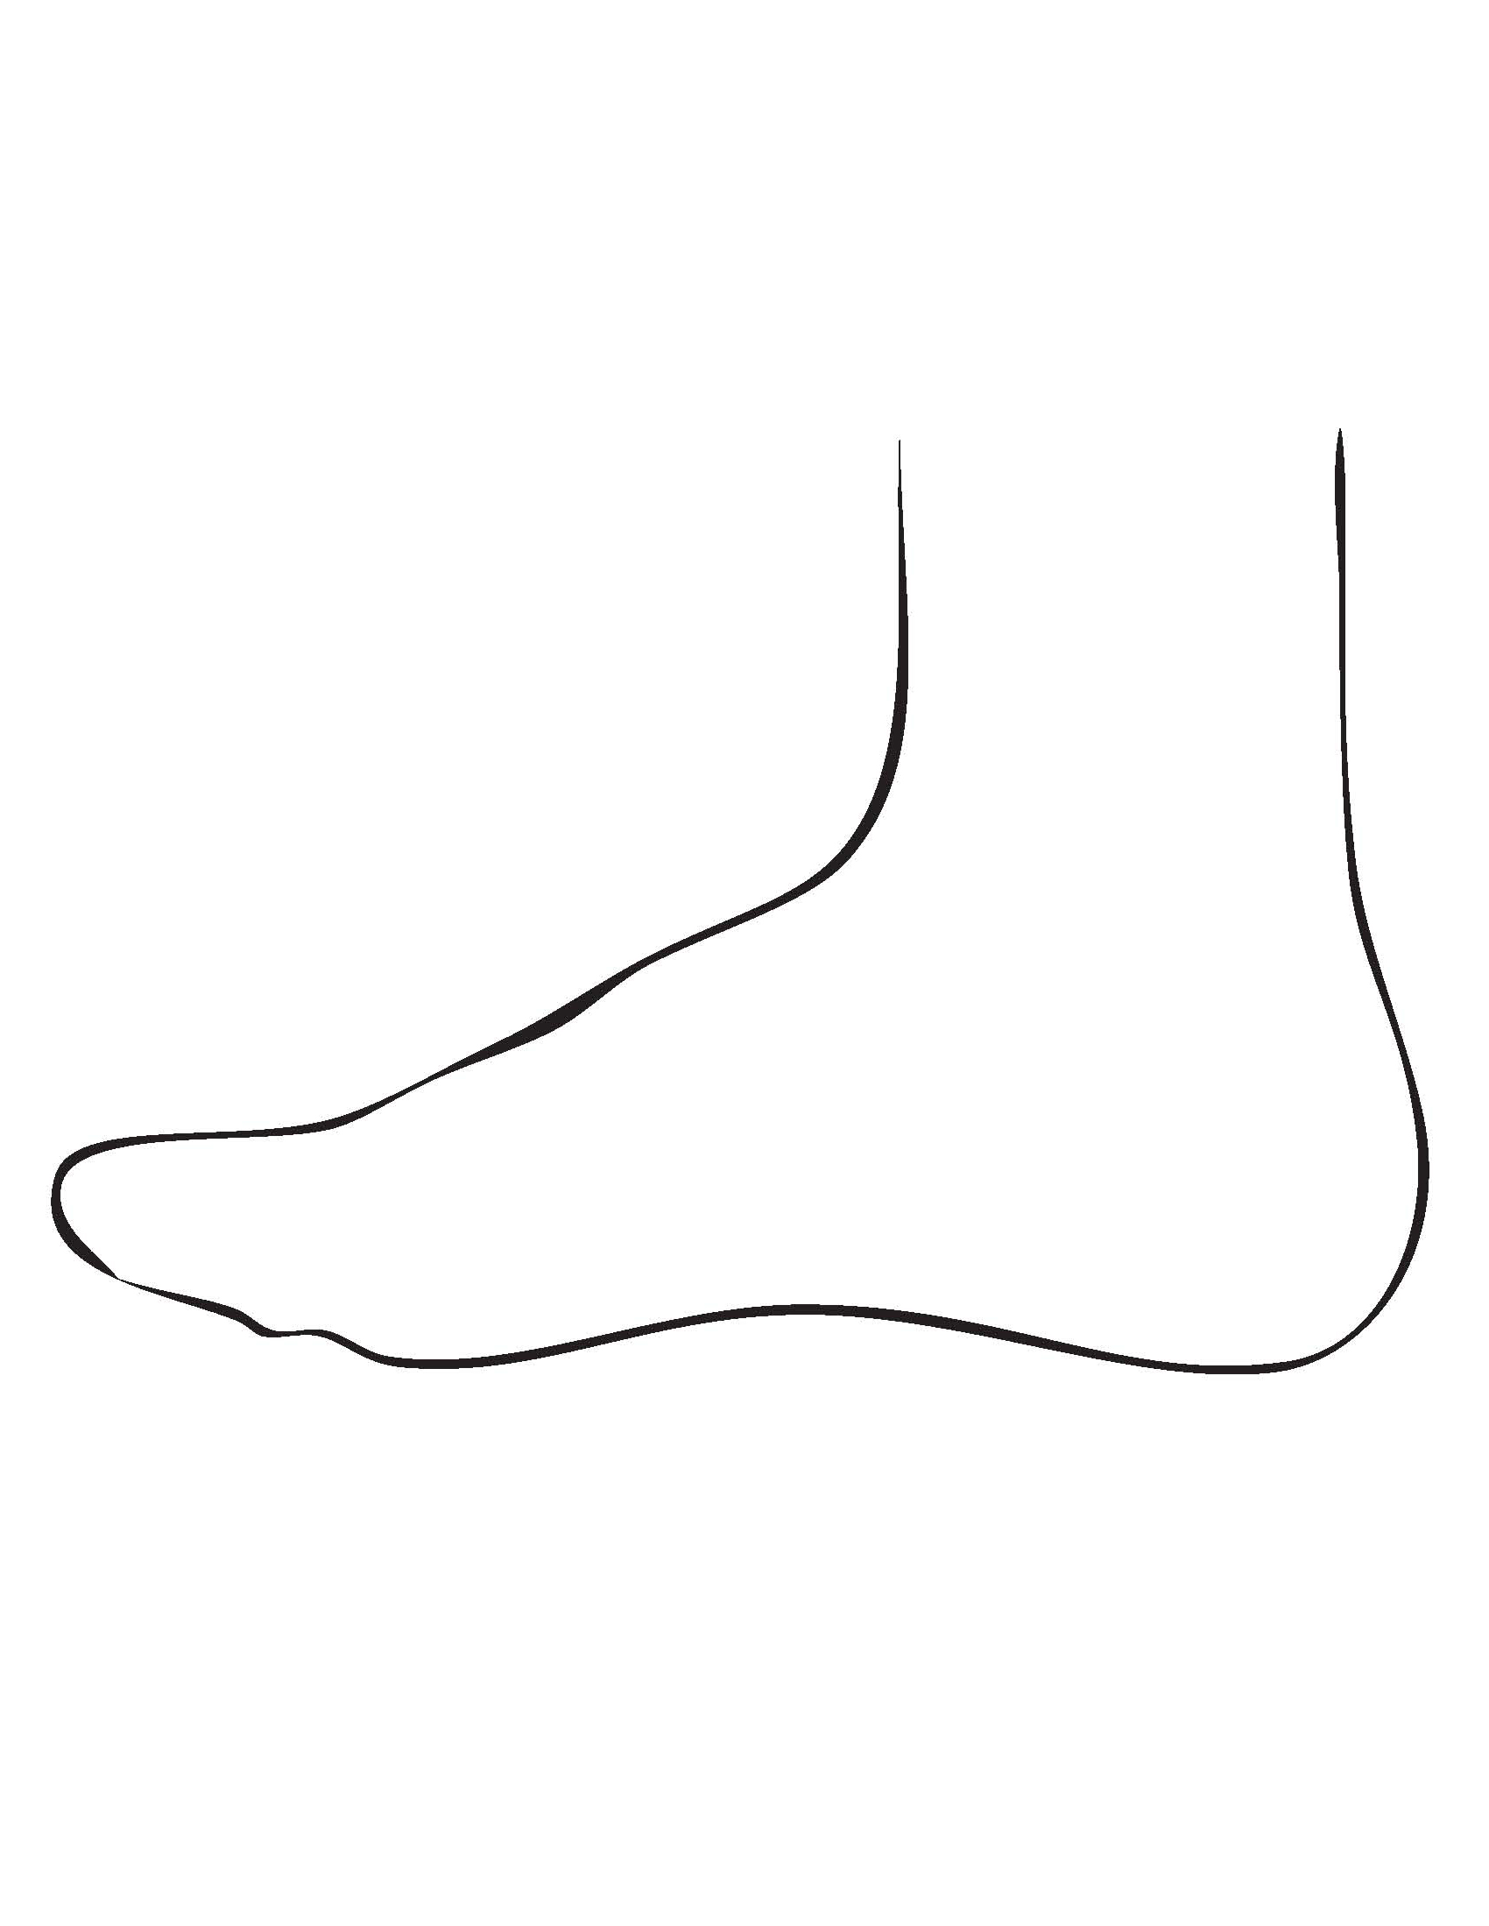
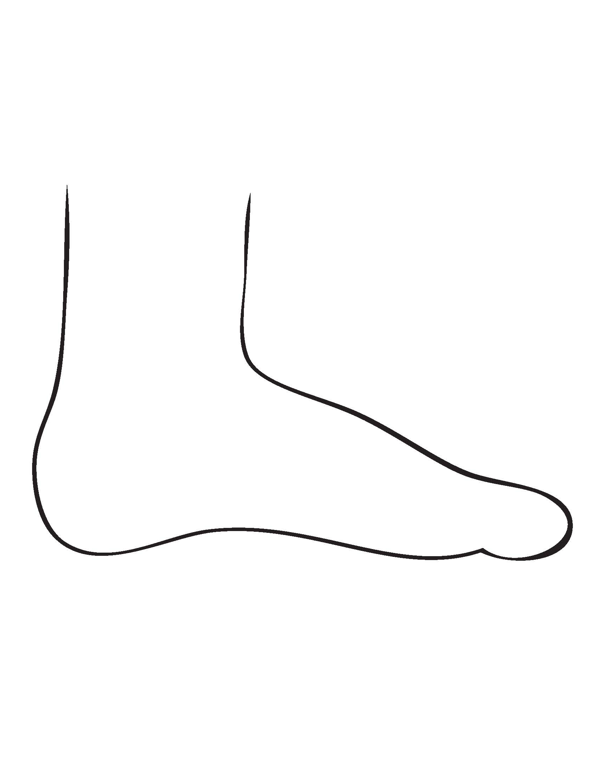
Top of Foot
Bottom of Foot
Bottom of Foot
Top of Foot

Inside of foot
Outside of Foot
Outside of Foot
Inside of foot

How long ago did this problem first start? __________ Days / Weeks / Months / Years

Did your pain or problem:  Begin all of a sudden  Gradually develop over time

How would you describe your pain?  No pain  Sharp  Dull  Aching  Burning
 Radiating  Itching  Stabbing  Other ________________________________________________

How would you rate your pain on a scale from 0 to 10? (please circle)
(no pain) 0 1 2 3 4 5 6 7 8 9 10 (worst pain possible)

Since the time your pain or problem began, has it:  stayed the same  become worse  Improved

What makes your pain or problem feel worse?  Walking  Standing  Daily activities
 Resting  Dress shoes  High heels  Flat shoes  Any closed toe shoe
 Running  Other ________________________________________________________________________________

What makes your pain or problem feel better? ____________________________________________________________

What treatments have you had for this problem? _________________________________________________________

How has this problem affected your lifestyle or ability to work? _______________________________________

Was this problem caused by an injury?  Yes (describe) _________________________________________  No

If yes, was it a work-related injury?  Yes  No

To the best of my knowledge, I have answered the questions on this form accurately. I understand that providing incorrect information can be dangerous to my health. I understand that it is my responsibility to inform the doctor and office staff of any changes in my medical status.

___________________________________________________ ___________________________________________________
Print name of patient, parent or guardian Signature of doctor

___________________________________________________ ___________________________________________________
If other than patient, relationship to patient Date

____________________________________________________
Signature

