 

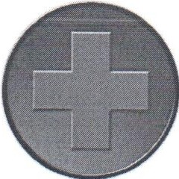***Familg Clinic al •aare11ille***

710Highway 371, Mooreville, MS 38857 [acutecaremooreville@gmail.com](mailto:acutecaremooreville@gmail.com)

Tel. 662.840.4577 Fax 662.840.4594

AUTHORIZATION FOR REQUEST OF MEDICAL RECORDS

# PATIENT INFORMATION (please print)

Name: Date of Birth: ------

Social Security Number:

Address: City/State/Zip:

Telephone Number: _

# RELEASE MY MEDICAL RECORDS FROM:

Clinic: -------------

Tel: ---------

Fax: ---------

# TO

Acute Care + Family Clinic of Mooreville 710 Highway 371, Mooreville, MS 38857

Tel. (662) 840-4577

Fax (662) 840-4594

I hereby give erisioto transfer my complete medical records, including but not limited to, progress notes, operative notes, laboratory results, and diagnostic tests to be housed permanently at Acute Care+ Family Clinic of Mooreville, Inc.. Any further transfer of records can be made by written request.

# BY MY SIGNATURE I AUTHORIZE THE TRANSFER OF MEDICAL RECORDS

PATIENT: _ E: _