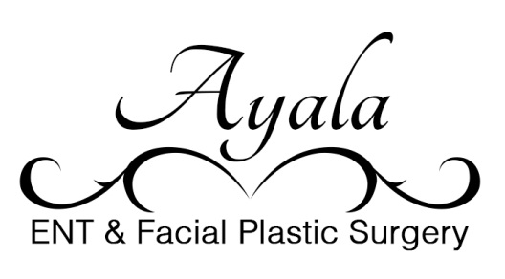
No Show Policy
We understand that you may sometimes need to reschedule appointments. When we make your appointment, please understand we are reserving time for you to see the provider. This courtesy makes it possible to give the best service here at Ayala ENT and Facial Plastic Surgery Institute.
If you need to reschedule an appointment, please call the clinic as soon as possible or call at least 24 hours in advance.
If you have no showed for your appointment, you will be charged a $20 no show fee.
We thank you for your trust in us here at Ayala ENT and Facial Plastic Surgery Institute.

_________________________ _____________
Patient signature Date

