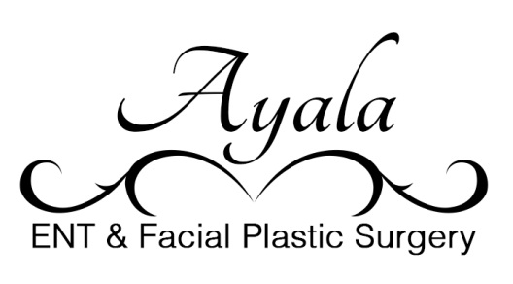
COVID 19 Medical Practice Consent

I, _______________________, understand that I am undergoing a procedure/office visit.
I also understand there is a COVID19 pandemic in the background. No one truly understands how many persons have been infected and are carriers. I understand your staff are taking all efforts to prevent all patients from contracting the illness. But, even with diligent efforts, that cannot prevent all cases. And some people are likely infected, but asymptomatic, before they even arrive at the office/facility. And after the procedure, the risk of my acquiring an infection, including COVID, is greater than not having the procedure done at all. ___ (Initials)
I understand you, the health care providers, will do your best to prevent my acquiring or developing a COVID infection. I understand if in the face of the pandemic, I do acquire such infection that general healthcare system will hopefully have access towards providing state of the art care, but cannot be guaranteed. ___ (Initials)

I have been given a description of the options to this procedure, including delaying treatment or having no treatment at all. In views of this, I elect to proceed. ___ (Initials)

____________________________ (signature/Date)

