CAWTHORNE-COOKSEY EXERCISES

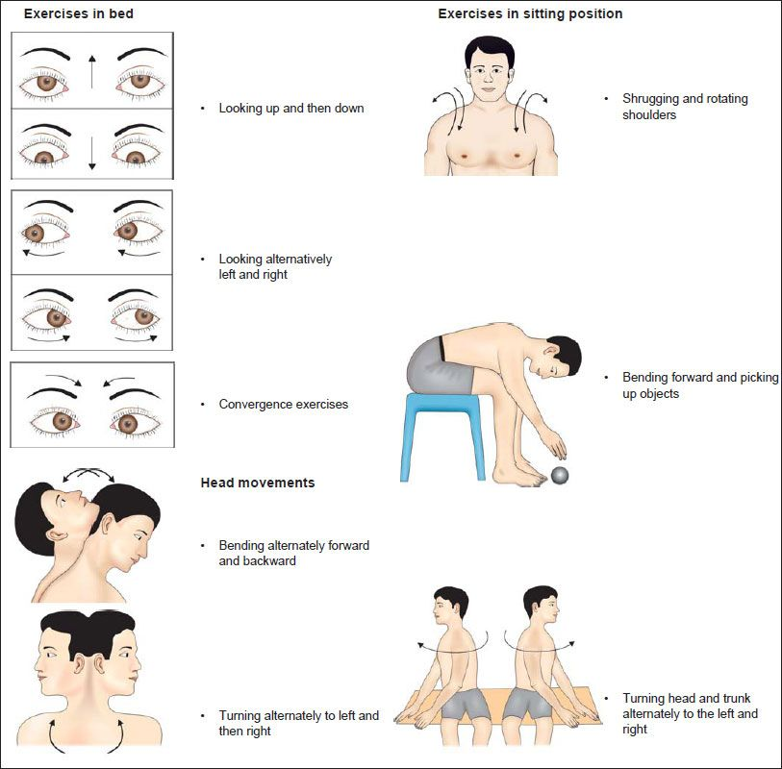
This is a one page handout of activities that progress from simple head movement to complex activities such as throwing a ball.
SITTING IN BED: eye movements- at first slow, then quick: 1. up and down 2. side to side
Head movements- at first slow, then quick; later with eyes closed: 1. bend forward and backward 2. turn from side to side
SITTING: eye movements and head movements as above; shoulder shrugging and circling, bend forward and pick up objects from the ground
STANDING: eye, head and shoulder movements as before; changing from sitting to standing with eyes open and shut; throwing a ball from hand to hand (above eye level) ; throw a ball from sitting to standing and turn around in between
MOVING ABOUT: (in class) circle around center person who will throw a large ball and to whom it will be returned; walk across room with eyes open then closed; walk up and down slope with eyes open then closed; walk up and down steps with eyes open then closed; any game involving stopping and stretching and aiming such as bowling and basketball
Diligence and perseverance are required but the earlier and more regularly the exercise regime is carried out, the faster and more complete will be the return to normal activity. Ideally, these activities should be done with a supervised group. Individual patients should be accompanied by a friend or relative who also learns.

