VOR EYE EXERCISES
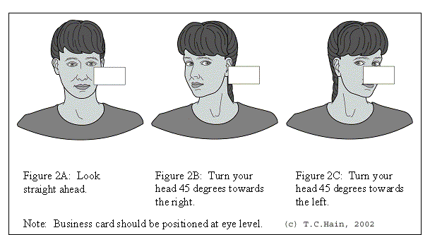
Sitting Exercises
- Take an item to read, hold it in front of you, move your head back and forth, up and down, around in circles both directions, as fast as you can and still be able to read the words on the page. Do each direction for about one minute, mix up the direction.
- Hold two items about arm’s length apart, move head quickly from one to other, up/down, side to side, for about one minute. Stay only long enough to establish focus, then move your head quickly back to the other object.
You should spend about 5 minutes, 2 to 3 times a day, performing the above exercises.
The primary role of the inner ear and vestibular system is to allow you to keep your eyes stable and focused on objects as you move your head around. The goal of these exercises is to enhance the communication between your inner ears and your eyes. The brain uses the inner ear information to determine how much eye movement is needed to allow your eye to stay fixed on an object as you move around.
If you move fast enough that the brain perceives difficulty staying fixed and focused, the brain may increase the signal from the inner ear to adjust. Over time you will be able to move faster and still maintain visual stability. Make sure you mix up the speed and direction of eye movement, because that will best simulate real-life situations. These exercises help you recover as quickly and as much as possible from most inner ear disorders. When you finish an exercise session, you should feel a little uneasy. That means you have pushed the system sufficiently to trigger progress. If you feel perfectly fine, you are probably moving too slow. If you feel very nauseous, you are probably moving too fast.

