# **Manage SFTP Password (Self-Serve UI)**

“Manage SFTP Password” link will be added to the My Account > Manage Products tab under the Manage Products section.

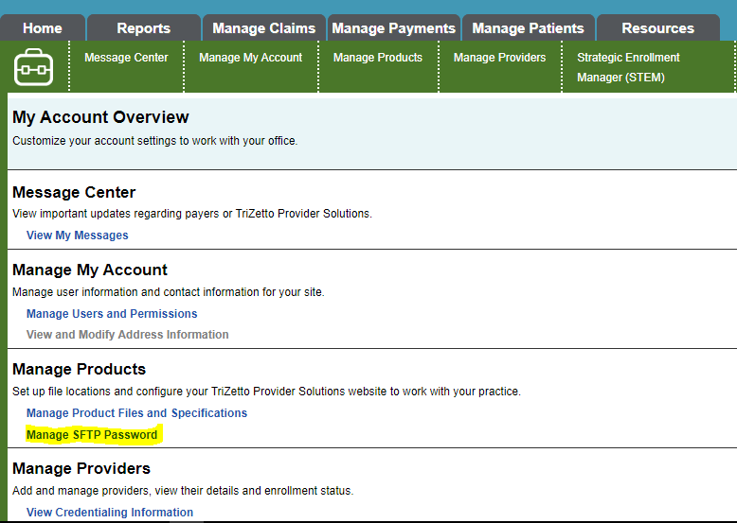

When clicked, the Manage SFTP Password page appears:

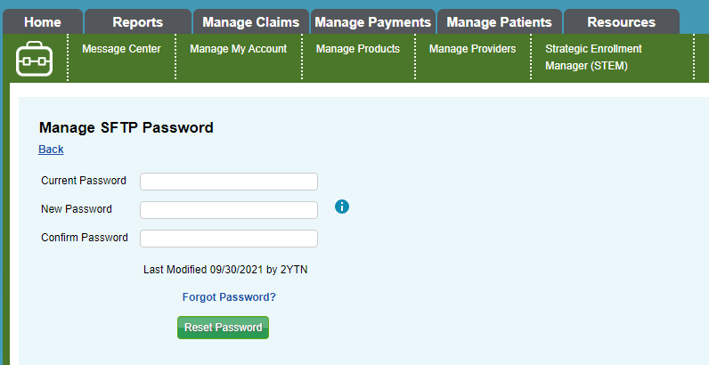

This page allows the user to:

1. Reset their password, by entering appropriate values in each field and clicking the Reset Password button
2. Unlock their account, by clicking “here” in the “If your account is locked, click here to unlock it” link.
3. Reset their password even if they forgot their current password, by clicking the Forgot Password? link, which will display a similar looking page allowing them to reset the password without entering the current password.
4. See password complexity requirements, by clicking the info icon behind the New Password field.

SFTP Password Requirements:

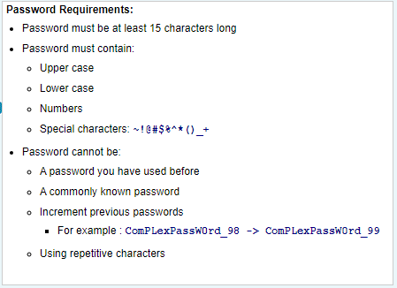

SFTP Reset Password Page:

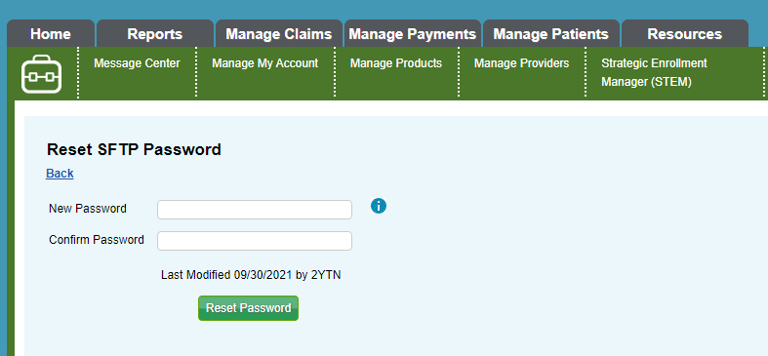

SFTP Password Page – Account Locked- Out

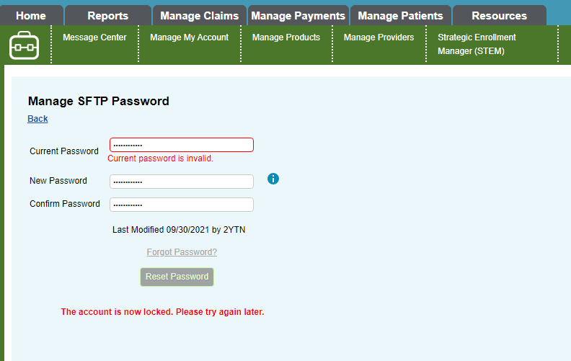

SFTP Forgot Password Page – Account Unlock Link

